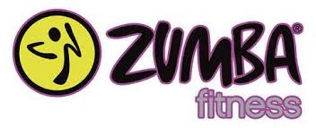
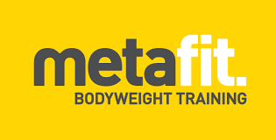
TERM 4 GROUP FITNESS TIMETABLE
ABBA Fitness Classes

effective Monday 7th October
to Saturday 21st December 2019

 | 6:00am | 7.15am | 9.20am | 2.30pm | 7.15pm
MON | METAFIT  (*CCH)  30 mins
TUES | PENALTY BOX  (*MPH)  45 mins |  | TRAINER’S CHOICE  (*CCH)  45 mins
WED | BOXING  (*MPH)  45 mins |  |  |  | METAFIT  (*MPH)  30 mins
THURS | RUNNING TRAINING  (ALL LEVELS)  MEET AT MPH  45 mins |  |  | TABATA BOOTY BLAST  (*MPH)  30 mins | ZUMBA  (*CCH)  45 mins
FRI | POWER PUMP  (*MPH)  45 mins |  | POWER PUMP  (*CCH)  45 mins
SAT |  | PENALTY BOX  (*MPH)  45 mins
*CCH-Community Centre *MPH Multipurpose Hall
For more details, contact Tracy on 0422 002 500 ktnaismith@iinet.net.au
11 week term –$174.00 or 2 instalments of
1st instalment (6 weeks) $95.00 / 2nd instalment (5 weeks) $79.00
(plus $15 AGCS annual family membership if not already paid)
www.agcsinc.org.au |enquiries@agcsinc.org.au | facebook/AGCSinc
103-105 Kearney Drive, Aspendale Gardens | 9587 5955

